## Return Postings Grid – Un-post Panels

If the wrong posting date was applied to one or more panels they will need to be un-posted first and you will need to go into the system and enter the correct date they were posted. Using the Enter Postings Grid allows to un-post panels.

From the Charting pull down menu choose the **Return Postings Grid** to open the following window.

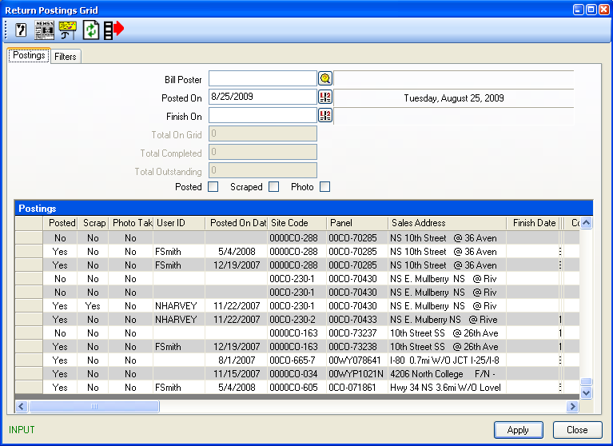

**Filters tab**

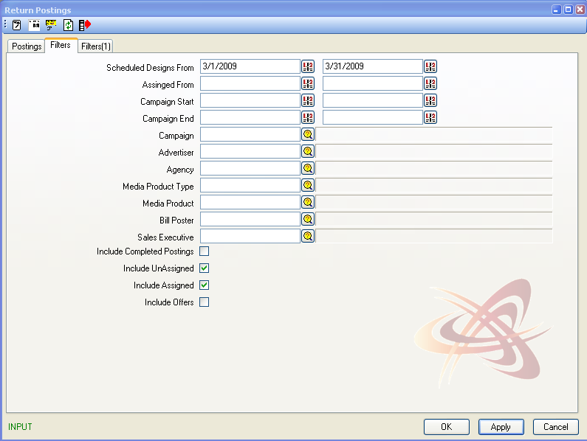

There are various filters that can be used to display the posted panels at the very least the contract number needs to be provided and the “Include Completed Postings” checkmark checked .

|  |  |
| --- | --- |
| **Scheduled Designs From** | Enter a date range that the creative was Scheduled to Post. Defaults to current month. |
| **Assigned From** | Enter a date range that the Operations department had scheduled to Post. |
| **Campaign Start** | Enter a date range to view campaigns beginning during that time. |
| **Campaign End** | Enter a date range to view campaigns ending during that time. |
| **Campaign** | Enter the Campaign code or click the browse button to search for a campaign. |
| **Advertiser** | Enter the advertiser code or click the browse button to search. |
| **Agency** | Enter the agency code or click the browse button to search. |
| **Media Product Type** | To view scheduling for a specific media product type, enter the code or select the appropriate type from the browse list. |
| **Media Product** | To view scheduling for a specific media product, enter the code or select the appropriate type from the browse list. |
| **Billposter** | To view scheduled postings assigned to a specific billposter or rotary crew, select the appropriate name from the browse list. |
| **Sales Executive** | To view scheduled posting associated to a specific Sales Person. |
| **Include Completed Postings** | To include completed postings in the list, click this check-box “on” |
| **Include Assigned** | To exclude scheduling that has been assigned to a billposter or rotary crew, click this check-box “off”. Selected to display by default. |
| **Include Unassigned** | To exclude scheduling that has not been assigned to a billposter or rotary crew, click this check-box “off”. Selected to display by default. |
| **Include Offers** | To include scheduling for panels charted to campaign details in the offer stage (not ‘Sold’), click this check-box “on”. By default only sold contracts appear. |
| **Extra Panel Filter** | The Extra Panel filter can also be used to apply further filters. |

Once you have selected one or more filter criteria, click the Refresh  button to review your filtered inventory.

To un-post a panel, in the Posted column double-click on the word “YES” in the row corresponding to the panel that was incorrectly posted. The Posted On Date will be removed.